***Machine Learning***

*Assignment 1*

*Group Members*

***Name ID No***

*K.Parameswar 2016A7PS0021H*

*E.Anish Reddy 2016A7PS0104H*

*K.Sandeep Chowdary 2016A7PS0070H*

***Fisher’s Discriminant Model***

***Results:***

***Dataset-1:***

*W1 = 8.28066108024304e-05*

*W2 = 0.009880760417003115*

*Slope of the line = 119.32332843059811*

*Threshold = 0.01619926*

* *Green Line is the line on which the points are to be projected.*
* *Magenta Line is the discriminating line.*
* *Blue points are of class-0.*
* *Red points are of class-1.*

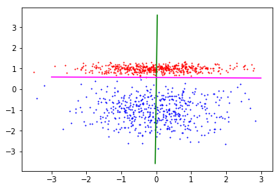

* *Normal Distributions of the class-0 and class-1 points*
* *Blue points are of class-0.*
* *Red points are of class-1.*
* *Green Point is the threshold value.*

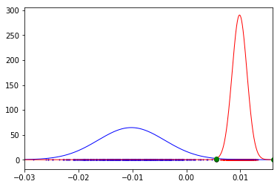

* *Points after projected to one-dimension.*
* *Blue points are of class-0.*
* *Red points are of class-1.*
* *Black Point is the threshold value.*

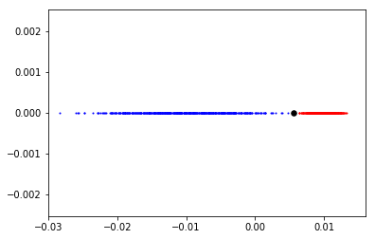

***Dataset-2:***

*W1 = 0.00039785973112584457*

*W2 = 0.012032862744630096*

*Slope of the line = 30.243982497499992*

*Threshold = -0.00183085*

* *Green Line is the line on which the points are to be projected.*
* *Magenta Line is the discriminating line.*
* *Blue points are of class-0.*
* *Red points are of class-1.*

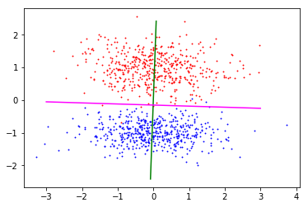

* *Normal Distributions of the class-0 and class-1 points*
* *Blue points are of class-0.*
* *Red points are of class-1.*
* *Green Point is the threshold value.*

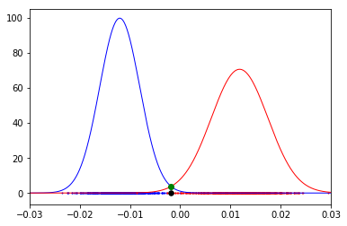

* *Points after projected to one-dimension.*
* *Blue points are of class-0.*
* *Red points are of class-1.*
* *Black Point is the threshold value.*

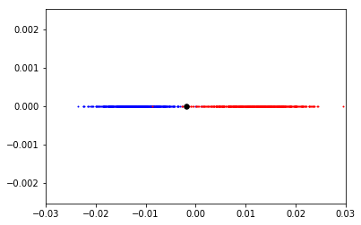

***Dataset-3:***

*W1 = -0.00039666231713113975*

*W2 = 0.02252931703518683*

*Slope of the line = -56.797220361465435*

*Threshold = -0.00885568*

* *Green Line is the line on which the points are to be projected.*
* *Magenta Line is the discriminating line.*
* *Blue points are of class-0.*
* *Red points are of class-1.*

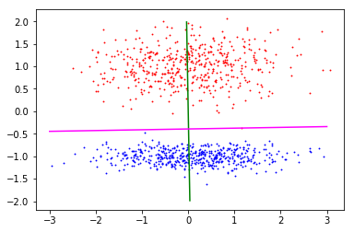

* *Normal Distributions of the class-0 and class-1 points*
* *Blue points are of class-0.*
* *Red points are of class-1.*
* *Green Point is the threshold value.*

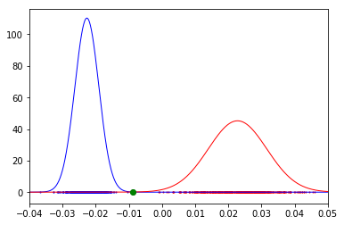

* *Points after projected to one-dimension.*
* *Blue points are of class-0.*
* *Red points are of class-1.*
* *Black Point is the threshold value.*

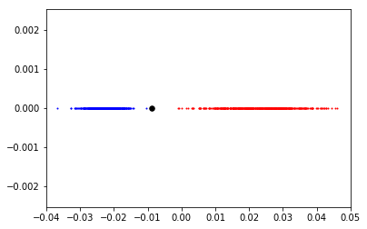

***Perceptron Discriminant Model***

***Results:***

*For 100 iterations and learning rate of 0.001*

***Dataset-1:***

*Scatter Plot of points:*

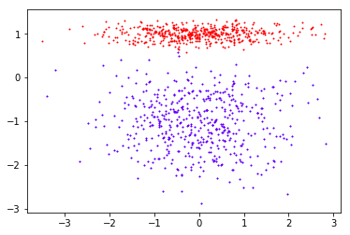

*Initial Values:*

*W = 0, 0, 0*

*Final W = 0.00029879, 0.01399658, -0.008*

**

*Initial Values:*

*W = -0.3, -0.5, -0.7*

*Final W = -0.0108271, 0.24970794, -0.147*

**

*Initial Values:*

*W = -0.1, -0.5, -0.2*

*Final W = -0.00094255, 0.05900398, -0.034*

**

***Dataset-2:***

*Scatter Plot of points:*

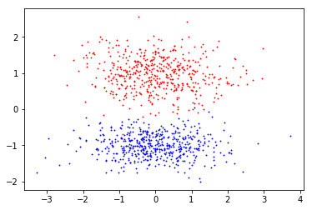

*Initial Values:*

*W = 0, 0, 0*

*Final W = 0.00040743, 0.00888904, 0.002*

**

*Initial Values:*

*W =* *-0.3, -0.5, -0.7*

*Final W = -0.01290801, 0.14188132, 0.025*

**

*Initial Values:*

*W = -0.1, -0.5, -0.2*

*Final W = 0.00041183, 0.00858367, 0.002*

**

***Dataset-3:***

*Scatter Plot of points:*

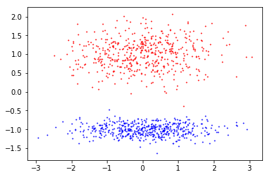

*Initial Values:*

*W = 0, 0, 0*

*Final W = 0.00057518, 0.00435358, 0.001*

**

*Initial Values:*

*W = -0.3, -0.5, -0.7*

*Final W = 0.03891374, 0.2177631, 0.037*

**

*Initial Values:*

*W = -0.1, -0.5, -0.2*

*Final W = 0.00815864, 0.04589638, 0.009*

**

***Observations:***

*Difference between the datasets with respect to the perceptron convergence theorem:*

* *Perceptron algorithm on dataset-1 takes roughly 50 iterations to reach a state where the ‘w’ divides the points belonging to two classes with 100% accuracy.*

* *Perceptron algorithm on dataset-2 doesn’t divide all the points correctly even after 100 iterations. Any number of iterations cannot divide the points accurately because the dataset-2 is not linearly separable from the scatterplot. With large number of iterations we may minimize the total error, but we can never achieve zero error.*
* *Perceptron algorithm on dataset-3 takes very few iterations to find a ‘w’ that divides the points of two classes correctly. This is because the points are linearly separable.*

*Impact of parameter initialization:*

* *For dataset-1:*
  + *With the initial value of w = [0, 0, 0], the final value of w = [0.00029879, 0.01399658, -0.008]*
  + *With the initial value of w = [0.1, 0.7, 0.5], the final value of w = [0.05356241, 0.62256558, -0.321]*
  + *With the initial value of w = [-0.1, -0.5, -0.2], the final value of w = [-0.00094255, 0.05900398, -0.034].*
* *For dataset-2:*
  + *With the initial value of w = [0, 0, 0], the final value of w = [0.00040743, 0.00888904, 0.002]*
  + *With the initial value of w = [0.1, 0.7, 0.5], the final value of w = [-0.06472321, 0.74546192, 0.134]*
  + *With the initial value of w = [-0.1, -0.5, -0.2], the final value of w = [0.00041183, 0.00858367, 0.002]*
* *For dataset-3:*
  + *With the initial value of w = [0, 0, 0], the final value of w = [0.00057518, 0.00435358, 0.001]*
  + *With the initial value of w = [0.1, 0.7, 0.5], the final value of w = [0.04787669, 0.75804083, 0.407]*
  + *With the initial value of w = [-0.1, -0.5, -0.2], the final value of w = [0.00815864, 0.04589638, 0.009].*

*For each dataset, with different initial w vector we are getting different final w vector although with very less variance. If we run for a few more iterations, may be the variance decreases.*

*Impact of training data ordering:*

*We have ran the perceptron algorithm using the training data with the original order and we have altered the ordering of the training data(reversed the data), the final W vector of values differed for both the models with same initial W vector, same learning rate and same no of epochs.*

*For Dataset-1,*

*With original ordering, w = [-0.00094255, 0.05900398, -0.034]*

*With altered ordering, w = [0.00035417, 0.04245725, -0.024]*

*For Dataset-2,*

*With original ordering, w = [0.00041183, 0.00858367, 0.002]*

*With altered ordering, w = [0.00047341, 0.00778142, 0.001]*

*For Dataset-3,*

*With original ordering, w = [0.00815864, 0.04589638, 0.009]*

*With altered ordering, w = [0.00837396, 0.04572761, 0.009]*